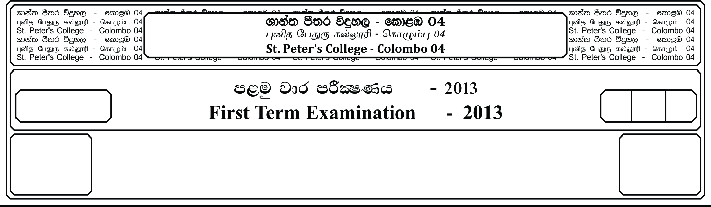

E

**idudkH bx.%Sis -**

**General English –**

**m<uq jdr mÍCIKh - 2019**

**Third Term Examination - 2019**

meh 02

02 Hour

12 fY%aKsh

GRADE 12

01. Fill the blanks with the following prepositions.

**(Over , in , towards , to , of , by , between)**

The ability ______________ balance work, family and leisure time is a major factor that determines the quality ______________ life led ______________ people. Most of us have family and social obligations like responsibilities ______________ family, friends and community and personal interest. Any conflict ______________ these interests causes unhappiness, anxiety and stress, which ultimately leads to a drop ______________ productivity. However one need not despair. Companies, the world ______________ in an effort to balance the, work – life conflict, are striving to provide ‘family – friendly workplaces.’

**(07 Marks)**

02. Fill the blanks with correct verb, selecting from the brackets.

Ray Wijewardene ______________ **(is, was, will)** brilliant and innovative. He ______________ **(has, had, have)** an open and inquisitive mind. He ______________ **(found, finds, find)** practical solutions to problems ______________ **(face, facing, faced)** by ordinary Sri Lankans. One of his ______________ **(good, best, better)**. Known inventions ______________ **(was, is, are)** the land master. Before this, the ______________ **(imports, important, imported)** tractors ______________ **(used, using, use)** by farmers ______________ **(was, are, were)** too large and too expensive for the average farmer. The land master ______________ **(is, was, are)** ______________ **(much, many more)** affordable and ______________ **(many, much, more)** suitable for them, and therefore ______________ **(become, became, will become)** very popular.

**(13 Marks)**

03. Find the correct word and fill the blanks from the list given below.

**[Future , moment , enable , advanced , countries , impact , research , devices , connected , access]**

The internet of things is a name for the latest way that technology will ______________ how we live and work. At the ______________ , technology that is internet ______________ may be less in our lives. However, there are ______________ that are technologically ______________. In such countries, a lot of the ______________ they use not only have internet ______________ , but they are also ______________ to each other. A ______________ study says that in the ______________ there will be 26 billion connected devices. **(10 Marks)**

04. Underline the correct word ending by selecting from those given in brackets.

1. The consume **(ing, ers, ption)** are protected by very strict laws.

2. The educate **(ed, ional, ing)** policies of our country should be changed.

3. If a person in very economy **(ic, cal, cally)** he can become rich soon.

4. The environment **(al, alist, ing)** think that the earth can be saved.

5. It’s a politic **(ian, ally, cal)** motived propaganda so, the general public should be careful.

**(05 Marks)**

05. Underline the most appropriate word those given in brackets.

1. The teacher **(demanded, requested, refused)** the principal for a day’s leave.

2. Tea is **(imported, increased, exported)** from our country to other countries.

3. We should **(look forward, look after, look into)** our parents when they become old.

4. You need your parents **(consent, context, convene)** to join the trip.

5. Everyone’s **(communication, contribution, commission)** is essential to bring peace in Sri Lanka.

**(05 Marks)**

**Comprehension**

**01.** Read the following passage and do the activity that follow.

The weather forecaster of the future will be helped in his work by earth satellites. Special ‘weather satellites’ going round and round the earth in space will enable him to ‘see’ what the weather is like in far-off places, where there are no weather stations. He will able to see what the weather is like at the North Pole, or in a remote island of the Pacific Ocean. He will be able to tell when hurricanes or new storms are starting, and will be able to warn every one of their approach.

Already space scientists have done experiments in space with weather satellites. Using special television cameras fixed to satellites they have learnt how to send back to earth photographs of the clouds high above the earth surface. A sort of cloud never before seen from earth has already been discovered by a weather satellite. Weather forecasting is only one of the many way in which earth satellites can help us. Earth satellites are often travelling science laboratories. Space scientists can fix scientific instrument, telescopes and cameras inside and on the outside of earth satellites to find out many things about the earth and the space around it. The radio messages the satellites send back are teaching us new facts about the sun and the stars.

Write ‘True’ or ‘False’ beside each sentence in the space provided.

1. The weather forecasters of the future will not be helped by earth satellites ( ___________ )

2. The future weather forecasters will be able to predict the weather in far-off places such as North Pole

and remote island of the Pacific Ocean ( ___________ )

3. Space scientists have found through experiments that clouds high above the earth’s surface can be

identified with the help of weather satellites ( ___________ )

4. Earth satellites are not often regarded as travelling science laboratories ( ___________ )

5. Space scientist can fix scientific instruments, telescopes and cameras only on the outside of earth

satellites ( ___________ ) **(05 Marks)**

**02.** Select five words from the list and make meaningful sentences.

Achiever, Observant, Courage, Famous, Discover, Experience, Veteran, Accomplish,

Exhausted, Illustrious **(05 Marks)**

**03.** Read the following passage and answer the questions given below.

What is success? It means achievement of aims, attainment of set goals. Success brings with it wealth, fame, admiration and most important, fulfillment. Achievers of success are those who have the courage to continue despite obstacles. Infact, they are encouraged by failure which make them more determined to succeed.

Learning which gives knowledge alone is not sufficient to gain success. The key to success is the ability to recognize skills and developing them. To achieve success one must go beyond the limitations of knowledge and broaden one’s horizon. Reading opens the door to knowledge and our capacity to learn is endless. Most successful and famous people have educated themselves through reading good which introduced them to a variety of subjects and though provoking information.

To read and learn as well as to continue in your pursuit of knowledge perseverance is a vital factor. A person should have the insight , courage, and motivation to push through blockades analyse and find solutions to problems, be ready to take up challenges, be always open to correction and learning to reach their goals. Nothing worthwhile can be gained without working hard for it. It’s the same with success, it comes to those who seek it, work for it and develop their skills.

1. What is meant by success?

……………………………………………………………………………………………………....

**(01 Marks)**

2. Does simply attaining academic excellence bring you success?

……………………………………………………………………………………………………....

**(01 Marks)**

3. How does reading help to achieve success?

……………………………………………………………………………………………………....

**(01 Marks)**

4. Name two other factors which contribute to success?

……………………………………………………………………………………………………....

1. **arks)**

05. Give words similar in meaning to the following from the passage.

1 - never give up

2 - enough

3 - barrier

4 - reach desired objective

08. What is meant by

1. Broden one’s horizo

2. Take up challenges

3. Thought provoking **(10 Marks)**

**Dialogues**

01. Match the responses of the dialogue to complete the conversation.

A B

i. What field of business are you in? At Hilton, Colombo

ii. Are you a Canadian? I arrived here last Sunday

iii. Where did you stay? It’s a very beautiful place

iv. When did you arrive in Sri Lanka? Yes I am

v. What can you say about our country? Software

**(05 Marks)**

02. Complete the following conversation.

Interviewer :- Good Morning Sir, Thank you for giving me this opportunity to meet you.

Mr. Wijewardena :- …………………………………………….………………………………..

Interviewer :- Sir, You are well known as an illustrious son of the soil. Would you like

to part with us about this recognition.

Mr. Wijewardena :- ………………………………………………………………………………..

Interviewer :- What is your earliest invention?

Mr. Wijewardena :- ………………………………………………………………………………..

Interviewer :- What outstanding abilities you have to innovate such vehicle?

Mr. Wijewardena :- ………………………………………………………………………………..

Interviewer :- Sir, Sri Lankan government has honoured you with two awards as

“Vidyalothi” and “Deshamanya” How do you feel about these awards?

Mr. Wijewardena :- ………………………………………………………………………………..

Interviewer :- Thank you sir for sparing you precious time with me?

Mr. Wijewardena :- ………………………………………………………………………………..

**(10 Marks)**

**Writing**

01. Write a letter to a friend inviting her/him to spend the August vacation at your ‘Holiday Bungalow’ in

Nuwara Eliya. In your letter

♦ Offer your friend to spend the August vacation.

♦ Give an advice about the clothes He / She should bring.

♦ Inform him / her the activities you have planned. **(10 Marks)**

02. Write a paragraph about a famous person whom you admire. **(15 Marks)**